Assignment 1:

1. Create 2 resource groups rg-1 and rg-2 

2. Add storage account to rg-1 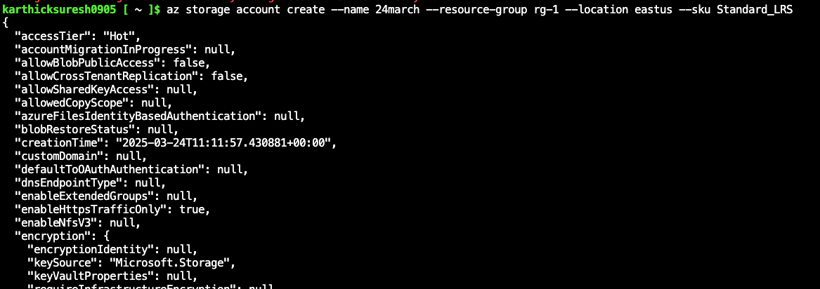

3. Move storage account from rg-1 to rg-2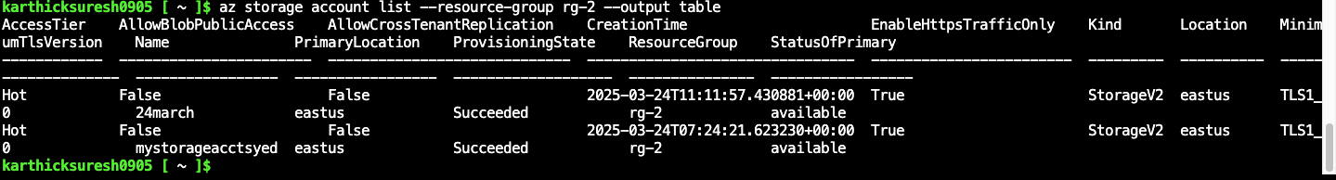

Assignment 2:

1. Create 3 storage accounts with “Team” tags: team1, team2 and team3 respectively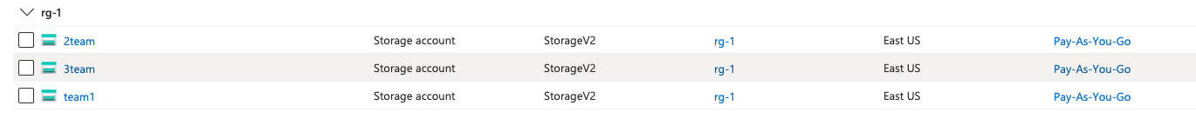

2. Create one more storage account for team2 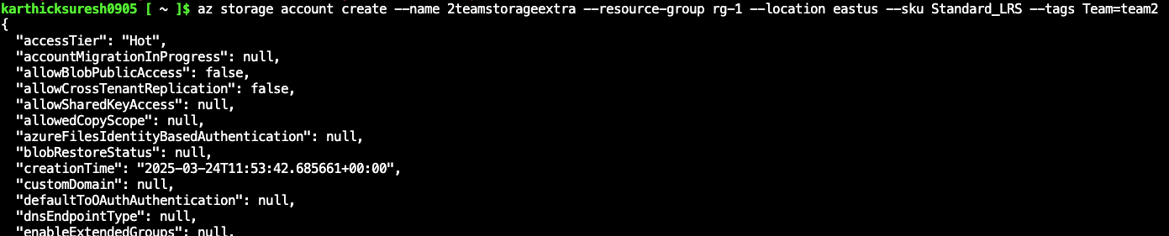

3. List all resources for team2 using tags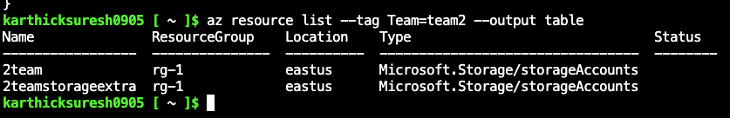

Assignment 3:

1. Create a file share in Azure Storage 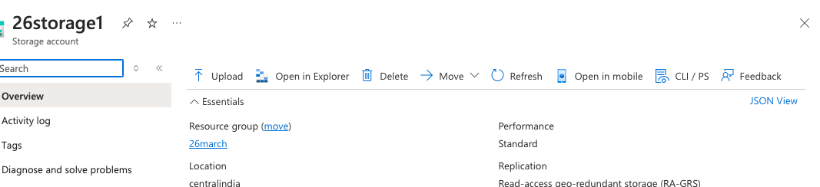

2. Mount this file share on Windows and Linux

windows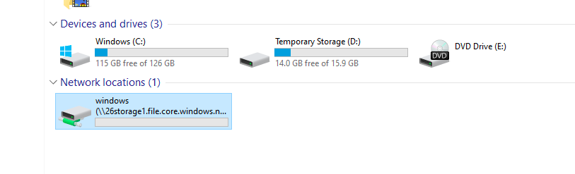

Linux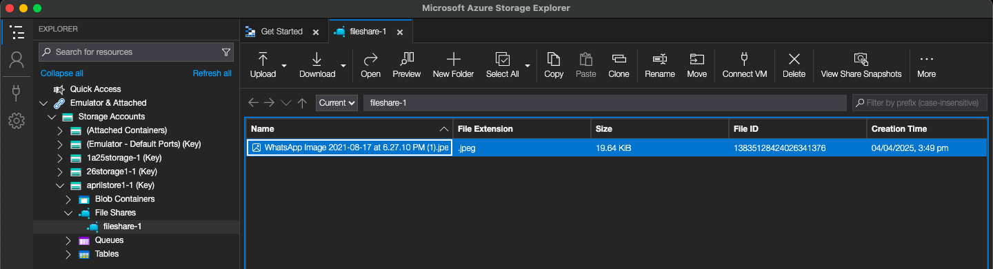

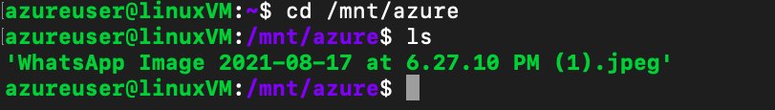

Assignment 4:

1. Create a Storage account, and upload some files in Blob storage 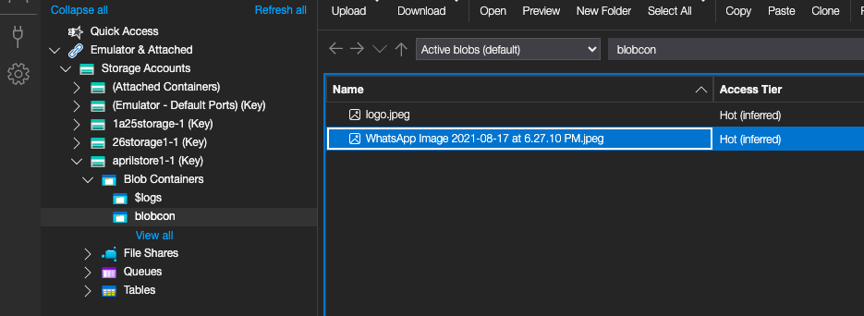

2. Create a CDN profile 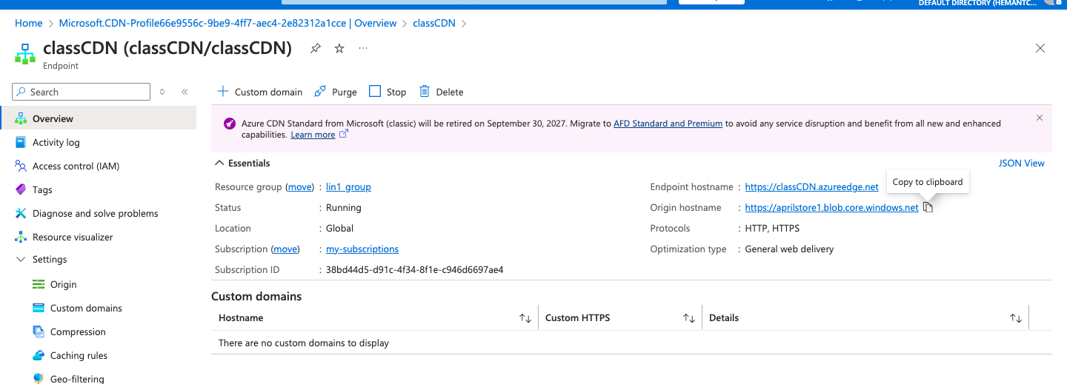

3. Create an endpoint and connect to the Azure Blob to access the files uploaded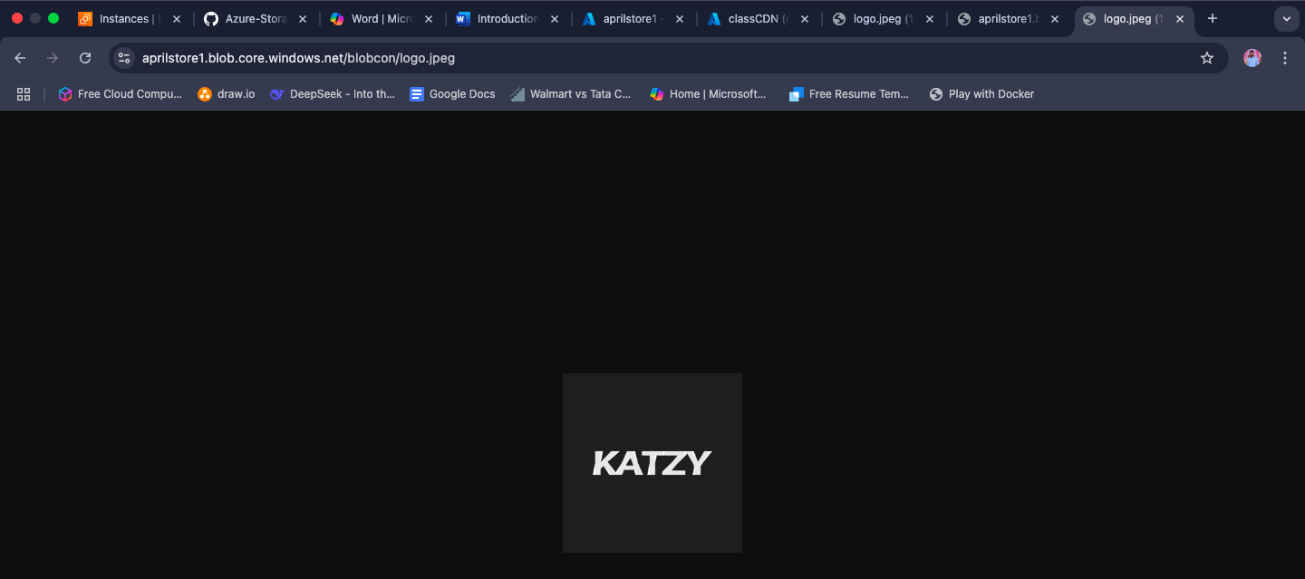

Assignment 5:

1. Create a storage account 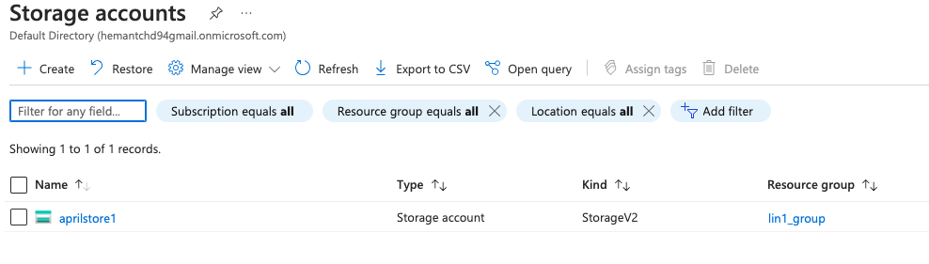

2. Use the Blob service and upload some files in it 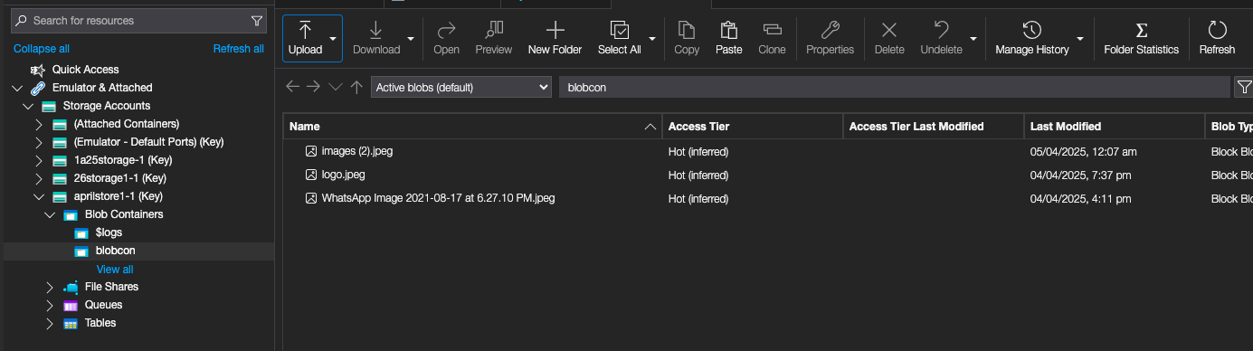

3. Change the access tier to archive